**Practical 01  
Identify the components of a personal computer (PC)**

In this practical, you will examine the motherboards of some personal computers and learn to categorize the components indicated in the pictures as:

1. Central Processing Unit (CPU) [ALU + Control Logic]
2. Memory
3. CPU Cache
4. Input/output, Network Interface Card
5. **Identifying the CPU of your own PC**
6. To find the exact processor model on your Windows 10 or Windows 8.1 computer, you can look for ‘***System Information***’ in search. On the detailed system informationpanel, you can identify the model of the processor (look for the model number).

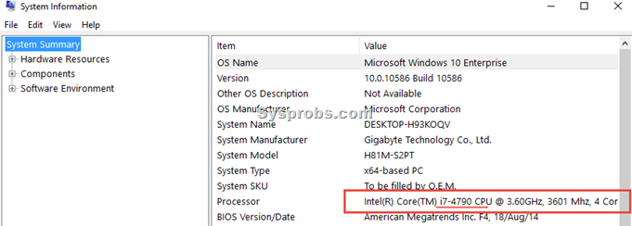

1. Write down your observation:

|  |  |
| --- | --- |
| **System Type (32bit or 64bit)** |  |
| **Processor Model** |  |
| **Number of CORES** |  |

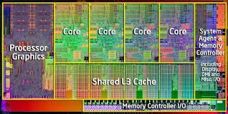

1. **Identifying the Memory of your own PC**
   1. Observe and write down the physical memory: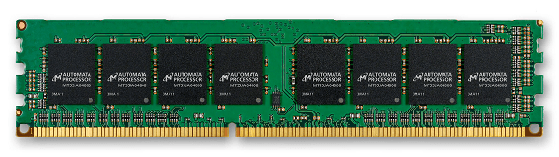

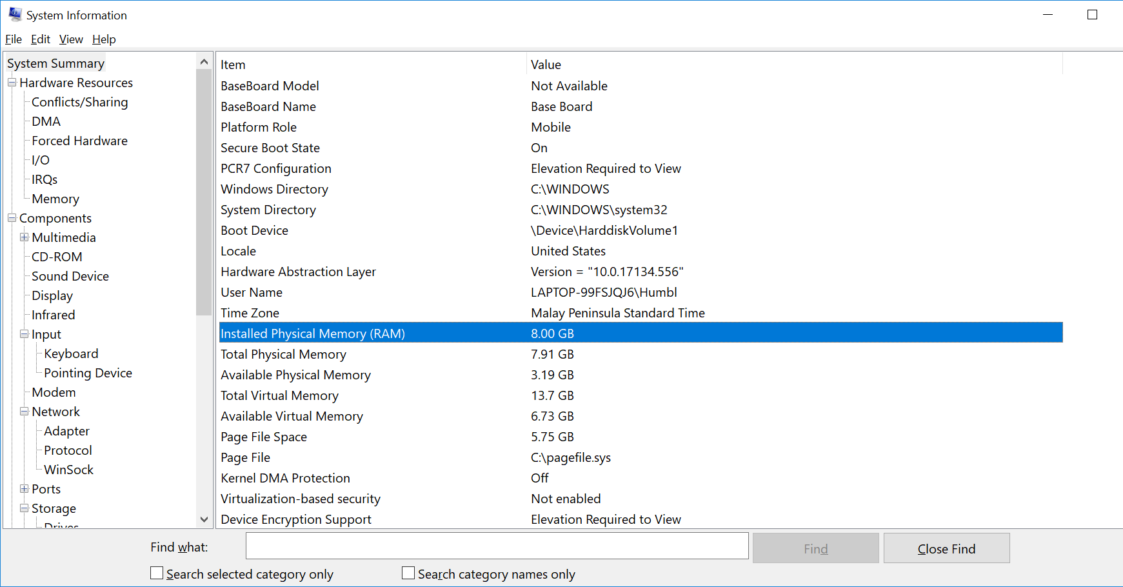

|  |  |
| --- | --- |
| **Size of the physical memory** |  |
|  |  |

|  |
| --- |
| Memory capacity: The more gigabytes (GB) your memory module has, the more programs you can have open at once.   * 2-4 GB. This was the standard RAM capacity and shipped with systems running Windows Vista or XP. This amount of memory could handle single applications. If your system has less than 4GB of RAM, adding more RAM would greatly improve its performance. * 4-6 GB. This standard RAM capacity will handle an average user's tasks, such as web browsing, working in Word documents, and emailing, with ease. * 6-8 GB. This larger RAM capacity works great for casual gamers and basic multimedia users. It can handle multiple programs open at one time and new technology so that users don't have to upgrade when their needs change. * 8+ GB. This robust RAM capacity is perfect for hardcore gamers and high-end multimedia users and creators. These users want to try the newest technology on the market without upgrading their RAM. |

Memory Speed: The amount of time that it takes RAM to receive a request from the processor and then read or write data. Generally, the faster the RAM, the faster the processing speed.

Search google to find the Speed of typical physical memory for your PC.

RAM speed is measured in Megahertz (MHz), millions of cycles per second, so that it can be compared to your processor's clock speed

1. **CPU Cache**
   1. Based on the model of the processor in previous step, search google for the CPU model, take note of the CPU CACHE size

|  |  |
| --- | --- |
| **CPU Cache size** |  |
|  |  |
|  |  |

* 1. Download and install cpu-z from [**https://www.cpuid.com/downloads/cpu-z/cpu-z_1.87-en.exe**](https://www.cpuid.com/downloads/cpu-z/cpu-z_1.87-en.exe)
  2. Check the CPU Cache size:

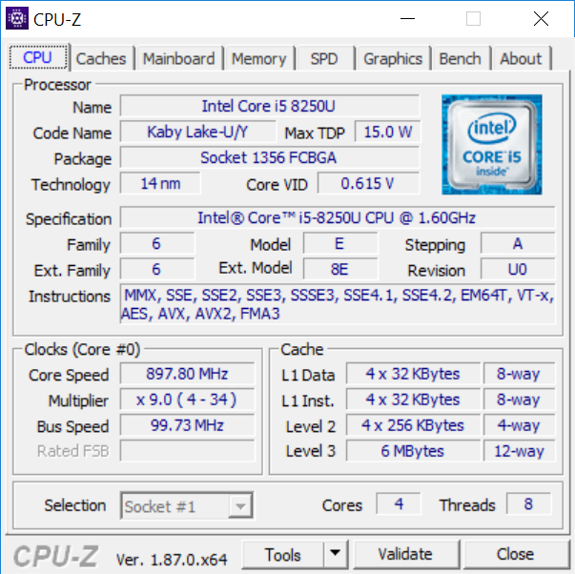

* 1. Take note and write down the Cache size:

|  |  |
| --- | --- |
| **L1 Data** |  |
| **L1 Inst** |  |
| **Level 2** |  |
| **Level 3** |  |

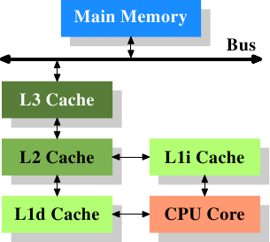

**Explain how CPU cache can enhance the computer speed by referring to the picture:**

|  |
| --- |
| **Explain how CPU cache can enhance the computer speed** |
|  |

* 1. RAM upgrades are limited by the capability of the system and the availability of expansion slots for adding RAM. Check if you have expanded RAM on your computer.  
       
     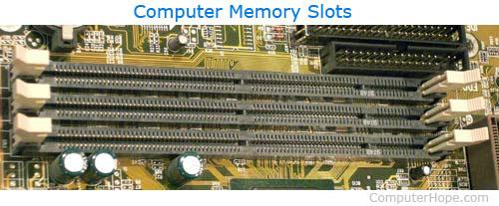

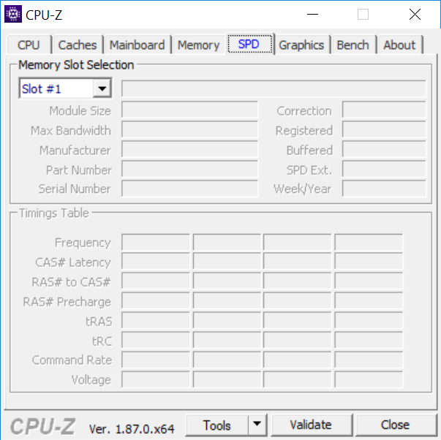

|  |
| --- |
| **How many slots are used for memory expansion?** |
|  |

1. **Network Interface Card**

## Ethernet Card

Ethernet card, also known as network interface card (NIC), is a hardware component used by computers to connect to Ethernet LAN and communicate with other devices on the LAN. The earliest Ethernet cards were external to the system and needed to be installed manually. In modern computer systems, it is an internal hardware component. The NIC has RJ45 socketwhere network cable is physically plugged in.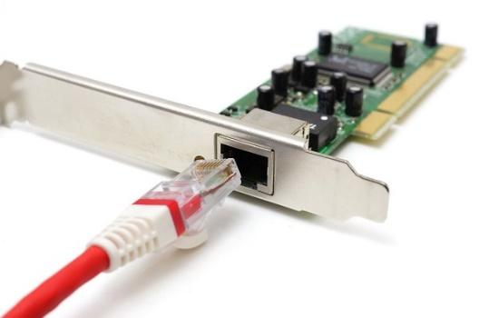

1. Go to command window by typing run cmd

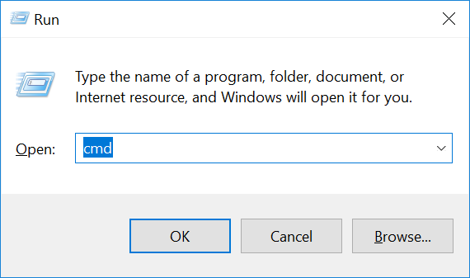

1. Type the following command in the command window

|  |
| --- |
| systeminfo |

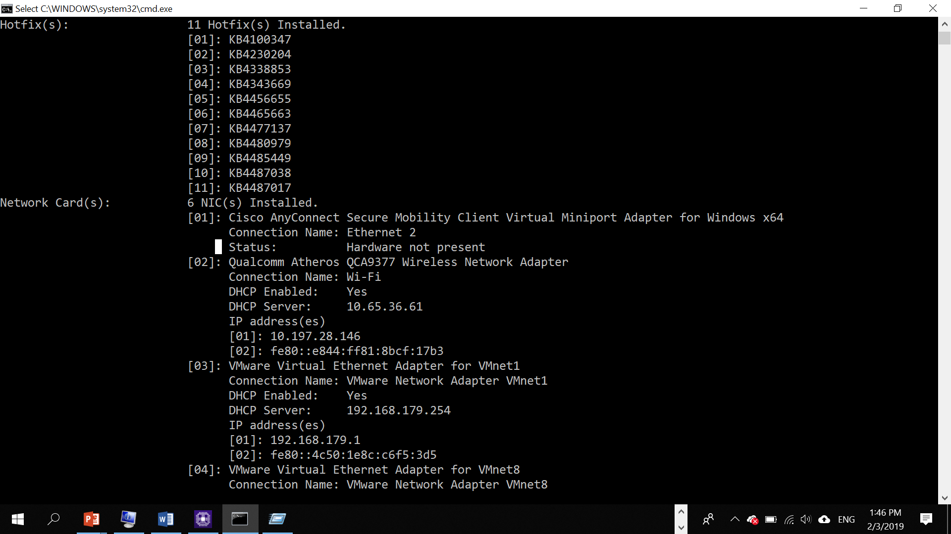

Type the command:

|  |
| --- |
| ipconfig /all |

1. Observe the result and record down:

|  |  |
| --- | --- |
| **Ethernet NIC** |  |
| **model** |  |
| **IP address** |  |
| **MAC address** |  |
| **Wireless NIC model** |  |
| **Model** |  |
| **IP address** |  |
| **MAC Address** |  |

1. Based on the model of wireless NIC, find the image of the card, for example: 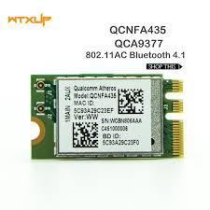

|  |
| --- |
| **Google Search for the following:**  How many bytes for MAC address?  What is MAC address for ?  If you change a new Wifi Card, will your MAC address also change? |

**Practical Reflection**

Suggested contents:

1. What have you learnt?  
2. Any difficulties encountered and how you solved the problems?

|  |
| --- |
|  |